Large Amplitude Pendulum

Equipment:

Qty | Components | Model #
1 | Small “A” Base | ME-8976
1 | 25 cm Long Threaded Steel Rod | ME-8988
1 | Pendulum Accessory | ME-8969
1 | Rotary Motion Sensor | PS-2120
1 | 550 Universal Interface | UI-5001
1 | PASCO Capstone | UI-5400

Introduction:

This experiment explores the dependence of the period of a simple pendulum on the amplitude of the oscillation. Also, the angular displacement, angular velocity, and angular acceleration for large amplitude are plotted versus time to show the difference from the sinusoidal motion of low amplitude oscillations. The student uses calculus to quantitatively see the relationships between the angular displacement, angular velocity, and angular acceleration curves.

A rigid pendulum consists of a 35 cm long lightweight (28 g) aluminum tube with a 75 g mass on each end, with the center of the tube mounted on a Rotary Motion Sensor (Fig. 1). When one of the masses is slightly closer to the center than the other mass, the pendulum will oscillate slowly enough to allow time to view the motion of the pendulum while also watching the real-time graph of displacement, velocity, and acceleration versus time.

The period is measured as a function of the amplitude of the pendulum and compared to theory. The student observes how an infinite series can be used to approximate the period and calculates the error in approximating the physical pendulum as a simple pendulum for angles of 90⁰ or less.

Theory:

The period of a physical pendulum is approximately given by

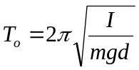 Eq. 1

for small amplitude (the error is less than 1% at 20º). I is the rotational inertia of the pendulum about the pivot point, m is the total mass of the pendulum, and d is the distance from the pivot to the center of mass, and g is the acceleration due to gravity. The approximation becomes exact as the amplitude goes to zero. In this limit the motion is simple harmonic and the angular displacement is given by:

θ = θ₀ sin (At + φ) Eq. 2

where θ₀ is the initial angular displacement, A is a constant called the angular frequency (= 2π/T₀), and φ is a constant called the phase angle which is determined by the value of θ when t = 0. The angular velocity and angular acceleration are then given by:

ω = dθ/dt = A θ₀ cos (At + φ) Eq. 3

α = dω/dt = -A² θ₀ sin (At + φ) Eq. 4

For larger amplitudes, the restoring torque is not linear and the period is given by an infinite series:

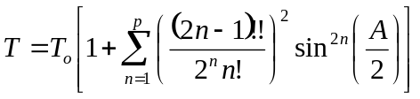 Eq. 5
where n is an integer and A is the amplitude (θ₀ in Equation 3 above). The first five terms are given by

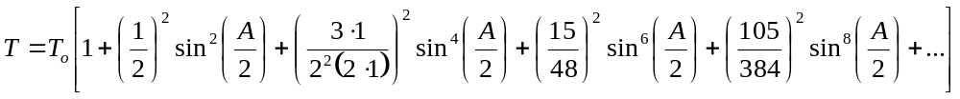 Eq. 6

Setup:

1. Thread the rod into the base and attach the Rotary Motion Sensor (RMS) as in Figure 1. Attach the RMS to any of the PasPort input on the 550 Universal Interface.

2. Remove the silver thumbscrew holding the pulley to the RMS. Put the large step of the pulley outward on the RMS and attach the pendulum rod at its center using the longer silver thumbscrew that comes with the rod. The rod should be positioned so the bumps on the pulley hold it in place.

3. Attach the two brass masses on the ends of the rod. One mass should be even with the end of the rod. The other should leave about 3cm of rod exposed above the mass.

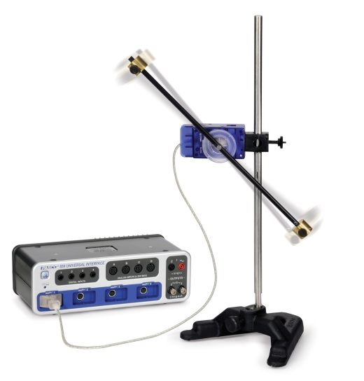
Figure 1: Setup
Procedure (Qualitative): (sensors at 100 Hz)

Small Amplitude

- Click on RECORD with the pendulum at rest in its equilibrium position. This will set the angle on the Rotary Motion Sensor to zero at the equilibrium position.
- Displace the pendulum by less than 20º (0.35 rad) from equilibrium. Let it go and click STOP after a few oscillations.
- Click open Data Summary at the left of the screen. Double click on Run #1 and rename it by “Small Amp”. Click Data Summary to close the panel.

Large Amplitude

- Click on RECORD with the pendulum at rest in its equilibrium position. This will set the angle on the Rotary Motion Sensor to zero at the equilibrium position.
- Displace the pendulum nearly 180º from equilibrium. Let it go and click STOP after a few oscillations.
- Click open Data Summary at the left of the screen. Double click on Run #2 and re-name it by “Large Amp”.

Analysis (Qualitative-small angle):

1. Click the black triangle by the Run Select icon on the graph toolbar and select “Small Amp”. Click the Scale to Fit icon.

2. Click Selection icon on the graph toolbar. Drag the handles on the Selection box so that it includes about two cycles after you have released the pendulum and it is swinging freely.

3. Click the Scale to Fit icon.

4. Click on the Remove Active Element icon to remove the Selection box. You may need to click inside the Selection box to highlight it first.

5. In the Legend box, click on θ to highlight the angle data. Click open the Selection icon. Drag the Selection box handles to highlight about two cycles of the angle data. Click the black triangle by the Curve Fit icon and select “Sine” from the pop up list. Click anywhere outside the pop up box to close it.

6. Answer Question 1 under the Qual Conclusions tab.

7. Click on the black triangle by the Curve Fit icon and de-select Sine.

8. Click on the Selection box to highlight it. Click on the Remove Active Element icon to delete the Selection box.

9. Repeat steps 5-8 for the “Ang Vel” data. Answer Question 2 under the Qual Conclusions tab.

10. Repeat steps 5-8 for the “Ang Accel” data. Answer Questions 3&4 under the Qual Conclusions tab.

Analysis (Qualitative-large angle):

1. Click the black triangle by the Run Select icon on the graph toolbar and select “Large Amp”. Click the Scale to Fit icon.

2. Click Selection icon on the graph toolbar. Drag the handles on the Selection box so that it includes about two cycles after you have released the pendulum and it is swinging freely.

3. Click the Scale to Fit icon.

4. Click on the Remove Active Element icon to remove the Selection box. You may need to click inside the Selection box to highlight it first.

5. In the Legend box, click on “θ to highlight the angle data. Click open the Selection icon. Drag the Selection box handles to highlight about two cycles of the angle data. Click the black triangle by the Curve Fit icon and select “Sine” from the pop up list. Click anywhere outside the pop up box to close it.

6. Answer Question 5-8 under the Qual Conclusions tab.

Conclusions (Qualitative):

1. Does the θ data fit a Sine curve as required by Equation 2 from Theory? Explain any discrepancy.

2. Does the “Ang Vel” data fit a Cosine curve as required by Equation 3 from Theory? Note that a Cosine curve is the same as a Sine curve shifted 90⁰ (1/4 wave) ahead in time.

3. Does the “Ang Accel” data fit a Sine curve as required by Equation 4 from Theory? What does the minus sign in Equation 4 do?

4. Are the periods of the three curves the same? How do you know?

5. Does the θ data fit a Sine curve as required by Equation 2 from Theory? Explain any discrepancy.

6. Do the "Ang Vel” and “Ang Accel” data fit a Sine curve as required by Equation 3 & 4 from Theory? Explain any discrepancy.

7. Although the three curves are not sinusoidal for large amplitude oscillations, the curves do have some similarities with the low amplitude behavior.

a. Why do the places where the speed is zero correspond to turning points where the displacement is maximum?

b. Why do places where the speed is maximum correspond to places where both the displacement and acceleration are zero?

8. Explain how the velocity curve implies the double peak with a valley in between that shows in the acceleration curve.

9. Move the pendulum so you can watch it and the computer screen at the same time (don't let the pendulum strike the screen!) Return to the previous page, click RECORD, and start the pendulum swinging at about 20º. Does the physical motion of the pendulum match the three curves on the graph?

Procedure (Quantitative): (sensors at 100 Hz)

- Slide the upper mass down until it is touching the pulley. Tighten the black thumbscrew that holds it in place.
- Click on RECORD with the pendulum at rest in its equilibrium position. This will set the angle on the Rotary Motion Sensor to zero at the equilibrium position.
- Displace the pendulum less than 5º (0.10 rad) from equilibrium. Let it go and click STOP after 13 oscillations.
- Click open Data Summary at the left of the screen. Double click on Run #3 and re-label it “Period Zero”. Click Data Summary to close the panel.
- On the graph, click Scale to Fit. Click on the Coordinate Tool icon.
- Move the Coordinate Tool box to the second (the first could be bad if you hand was still on the pendulum) peak. It will snap to the peak. Read the time and enter it in the table as t1.
- Move the Coordinate Tool to the 12th peak (ten periods later). Read the time and enter it in the table as t2.
- The zero amplitude period [(t2-t1)/10] will appear in the third column of the table as “Period zero”. Click open the Calculator (left of screen) and enter your value from the table in line 4, replacing my value of 1.037 s.
- Since the amplitude is decreasing, we will take an average by reading the amplitude of the center peak in the interval. Move the Coordinate Tool to the 7th peak. Record the amplitude (right hand number in the coordinate box) in the fourth column of the table.
- Enter the value for the Period in the table on the next page. To do this, enter the value for “Period zero” in the time 1 column with a minus sign (-1.035) and in the time 2 column with a + sign (+1.035). The Period column is averaged over two periods so should show the “Period zero” value (1.035). The “Amp” column carries over directly, but we must enter the time values as above since for the rest of the values will use two period averages instead of ten period averages.

Procedure C: (sensors at 200 Hz)

- Click on RECORD with the pendulum at rest in its equilibrium position. This will set the angle on the Rotary Motion Sensor to zero at the equilibrium position.
- Displace the pendulum by about 10º (0.20 rad) from equilibrium. The easiest way to do this is to watch the graph and slowly increase the angle until you get to 0.20 rad. Let the pendulum go and click STOP after 3 oscillations.
- On the graph, click Scale to Fit. Click on the Coordinate Tool icon.
- Move the Coordinate Tool box to the first zero angle crossing. Read the time and enter it in the table as time 1.
- Move the Coordinate Tool to the 5th zero angle crossing (two periods later). Read the time and enter it in the table as time 2.
- The Period [(time 2-time 1)/2] will appear in the third column of the table. Since the amplitude is decreasing, we will take an average by reading the amplitude of the center peak in the interval. Move the Coordinate Tool to the first positive peak. Record the amplitude (right hand number in the coordinate box) in the fourth column of the table (“Amp”).
- Repeat steps 1-7, each time increasing by about 0.2 rad (so 0.40 rad, 0.60 rad, etc) until you reach about 2.4 rad.

Series Approximation:

- Click open the Theory tab and click open the Calculator. Examine line 5 in the Calculator to verify that it is the same as Equation 6. To do this, double click on line 5, but do not make any changes! Line 5 is the same as Equation 6, except that I have added a constant “a” before the second term in the expansion, “b” before the third term, “c” before the forth term, and “d” before the fifth term. This allows us to shut off or enable terms by setting the constants to either 0 or 1. The constants are set in lines 6-9 of the Calculator and are currently all zero. This means T theory = T₀ for all amplitudes. When you’ve verified that they are the same, return to this page.
- Click open the Calculator. While observing the graph, change “a” in line 6 of the calculator from 0 to 1.
- Similarly, change “b”, then “c”, and then “d” from 0 to 1.
- Answer Question 1-3 on the Quant Conclusions page.

Quantitative Conclusions:

- Why is including only two terms (a=1, b=c=d=0) enough to match the data well for angles less than 45⁰ (0.8 rad)?
- Why does the approximation begin to fail for angles above 90⁰ (1.57 rad) even when we include all five terms in the approximation (a=b=c=d=1)?
- How many terms do you think would be required for the approximation to give a good value for the case where the amplitude equals 3.0 rad?
- The graph on the right shows the % error you would make in assuming that the Simple Harmonic Oscillator period given by Equation 1 from Theory was correct for all amplitudes.
  - How large is the error at an amplitude of 20⁰?
  - How large is the error at an amplitude of 45⁰?

